**AI/ML**

Project Report

Semester-IV(Batch-2022)

Spectrum

(Personality Detector)



|  |  |
| --- | --- |
| **Supervised by:**  Mr. Sachin Garg  (G-22) | **Submitted by:**  Ishaan Singla  2210992582 |

**Department of Computer Science and Engineering**

**Chitkara University Institute of Engineering & Technology,**

**Chitkara University, Punjab**

**Abstract**

The Spectrum project innovatively combines the Myers-Briggs Type Indicator (MBTI)personality assessment with advanced gesture recognition technology to create an engaging and accessible user experience. Utilizing Python, OpenCV, and Mediapipe, Spectrum enables users to complete the MBTI test through simple hand gestures—opening the hand for "YES" and closing it for "NO." This approach significantly reduces the cognitive load and potential barriers associated with traditional text-based questionnaires. OpenCV captures and processes video frames from the user's camera, while Mediapipe ensures accurate real-time hand tracking and landmark detection. Custom logic interprets these gestures as responses to the MBTI questions, facilitating a seamless and intuitive interaction. The Spectrum project not only enhances user engagement and accessibility but also modernizes personality assessment by integrating psychometric testing with cutting-edge technology, providing a fun and innovative way for individuals to gain self-awareness and insights into their personality traits.

**Introduction**

1. Introduction:

The Spectrum project revolutionizes the traditional approach to the Myers-Briggs Type Indicator (MBTI) personality test by integrating it with innovative hand movement recognition technology. This novel method transforms the process of taking the personality test, making it more engaging and accessible. Instead of answering a series of questions through conventional means, users can now respond using simple hand gestures: opening their hand for 'yes' and closing it for 'no'. This intuitive interaction mimics natural communication, offering a seamless and enjoyable experience. The integration of MBTI and gesture recognition aims to simplify the test-taking process, reducing the cognitive load and making it accessible to a broader audience, including those with reading difficulties or limited attention spans. By making personality assessment more interactive and fun, Spectrum enhances user engagement and provides valuable insights into individual personality types. This innovative approach not only modernizes the assessment method but also helps users gain a deeper understanding of themselves in a dynamic and user-friendly manner.

1. Objectives:

* To enhance Accessibility by simplifying the MBTI personality test process by allowing users to respond with hand gestures, making it more accessible to individuals with reading difficulties, limited attention spans, or physical disabilities.
* To increase Engagement by transforming the traditional test-taking experience into an interactive and enjoyable activity, encouraging more people to participate.
* To improve Accuracy by Utilizing hand movement recognition technology to minimize errors associated with traditional questionnaire-based responses, thereby enhancing the reliability of the test results.
* To Foster Self-Understanding by providing users with a fun and innovative way to explore their personality traits, promoting greater self-awareness and personal development.

1. Need:

Accessibility: Many people, including those with reading difficulties, physical disabilities, or limited attention spans, find traditional tests cumbersome. Simplifying the response method with hand gestures makes the test accessible to a broader audience.

Engagement: Traditional questionnaires can be monotonous, leading to disengagement and incomplete responses. An interactive, gesture-based system can make the process more engaging and enjoyable, increasing completion rates and user satisfaction.

Accuracy: Response errors can occur due to misunderstanding questions or answer fatigue in lengthy tests. A gesture-based system reduces these errors by simplifying the response mechanism.

Self-Awareness: People are increasingly interested in understanding their personality traits to improve personal and professional relationships. An innovative, easy-to-use tool can facilitate this self-discovery process effectively.

**Software Requirements**

Operating System: Windows 10

Python Environment: Python

Libraries and Dependencies:

* OpenCV: Used for video capture and frame processing.
* Mediapipe: Used for real-time hand tracking and gesture recognition.
* Tkinter: Creates a user-friendly interface for interaction.
* Time Integration: Incorporates the time library for efficient timing and synchronization within the application.

Additional Tools:

* Git: For version control.
* Virtual Environment: Recommended for managing project dependencies.

**Code Snippet:**

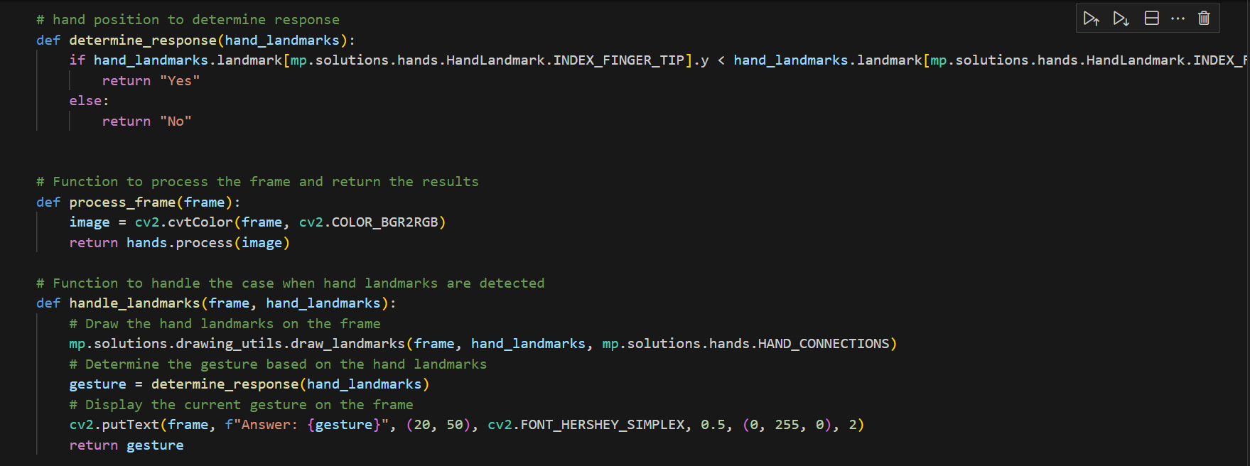

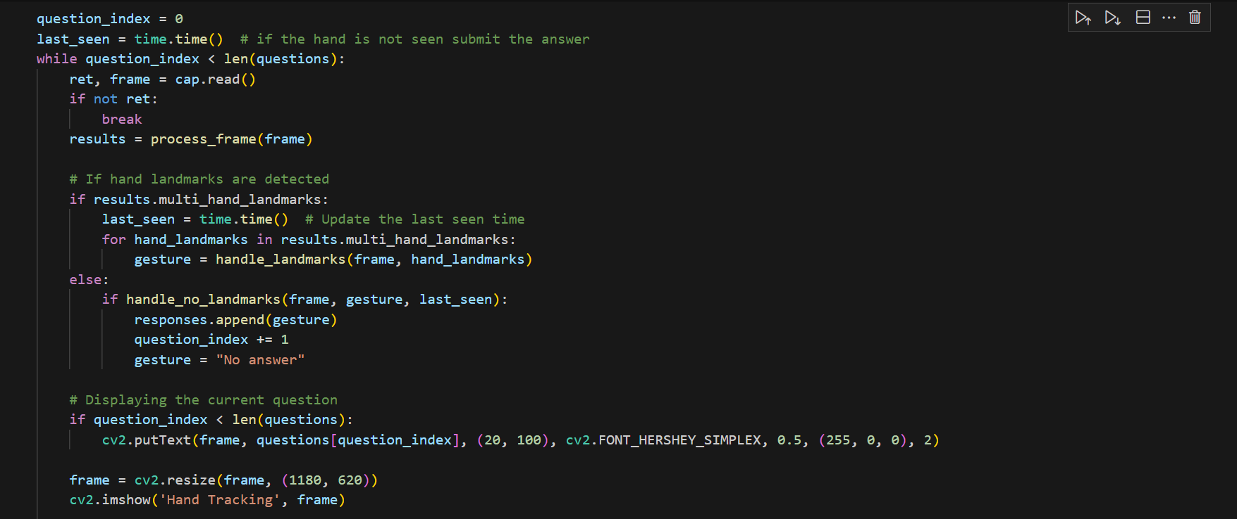

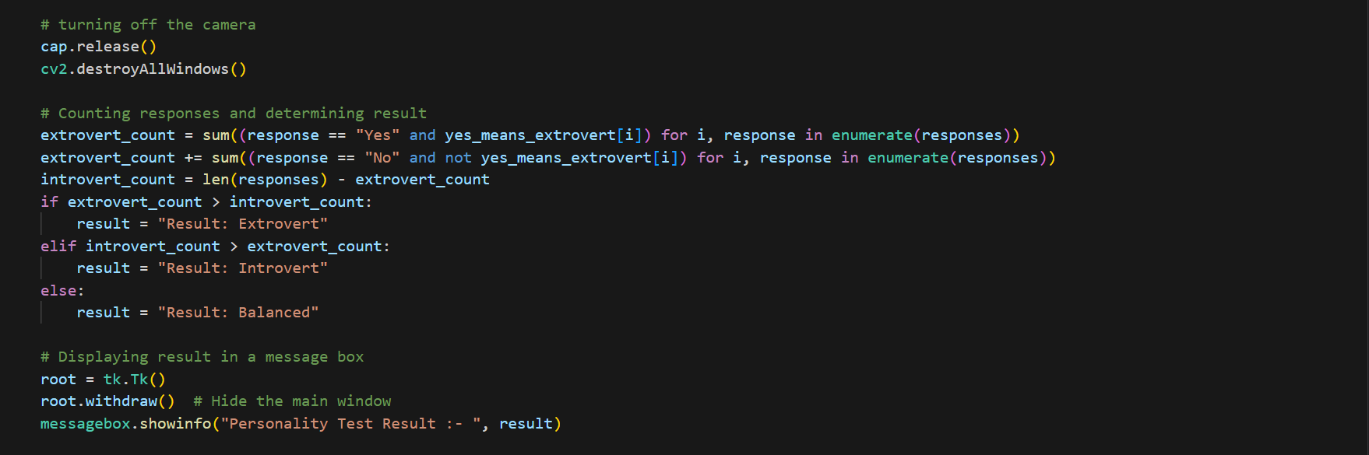

**Flowchart:**

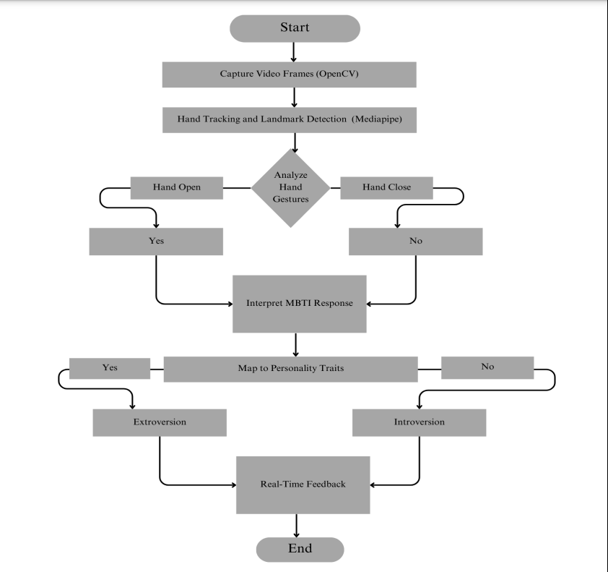

**Result:**

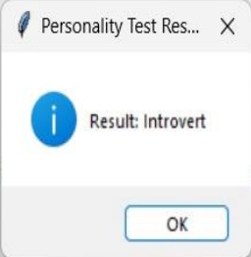

**Reference:**

* <https://www.16personalities.com/articles/energy-introverted-vs-extraverted>
* <https://developers.google.com/mediapipe/solutions/vision/gesture_recognizer>
* <https://www.google.com/>
* <https://stackoverflow.com/questions/60295760/detecting-and-tracking-the-human-hand-with-opencv>